SIMATS ENGINEERING
ASSESSMENT TOOL 2

COURSE NAME: INTERNET PROGRAMMING
COURSE CODE: CSA43
NAME: P SANJEEV(192324231)

COURSE OUTCOME COVERED

CO-1: Develop well-structured, standards-compliant web pages using HTML/XHTML and XML, and apply Internet protocols and HTTP communication mechanisms for web content delivery. (L2)

Assessment Tool: Data Interpretation (Medium)

Weightage: 20%

QUESTIONS: Total Marks: 20

1: HTTP Response Analysis
A web server returns the following HTTP response header:
HTTP/1.1 200 OK
Date: Mon, 01 Apr 2026 10:00:00 GMT
Content-Type: text/html
Content-Length: -150
Connection: keep-alive

Questions:
- Identify any incorrect or invalid fields in the header.
- Analyze the issue with Content-Length and explain its impact.
- Determine whether the status code matches the response correctness.
- Suggest corrections for the identified errors.

2: DOM Structure Analysis

Consider the following DOM tree representation:

<html>
<head>
<title>TestPage</title>
</head>
<body>
<div>
<p>HelloWorld
</div>
</body>
</html>

Questions:
- Identify missing or improperly closed elements.
- Analyze how the browser will interpret this structure.
- Determine the impact on rendering and layout.
- Suggest corrections to make the DOM valid.

3: GET vs POST in Login System
A login system uses two different methods:

Method | URL Example | Data Visibility | Security Level
GET | /login?user=admin&pass=1234 | Visible in URL | Low
POST | /login | Hidden in body | Moderate

Questions:
- Interpret the differences in data transmission between GET and POST.
- Analyze which method is more suitable for login and why.
- Identify security risks in using GET for authentication.
- Suggest best practices for secure login implementation.

4: HTML Code Inspection
Analyze the following HTML snippet:

<!DOCTYPE html>
<html>
<head>
<title>Sample</title>
</head>
<body>
<h1>Welcome
<p>This is a paragraph
<img src="image.jpg">
</body>
</html>

Questions:
- Identify missing closing tags.
- Analyze issues with the <img> tag.
- Determine how browsers will handle these errors.
- Suggest a corrected version of the code.

5: Browser-Server Communication Flow
The following sequence describes a web request:
- User enters a URL in the browser
- DNS lookup occurs
- HTTP request is sent
- Server processes request
- Response is returned
- Browser renders page
Questions:
- Interpret each step in the communication flow.
- Identify where delays can occur.
- Analyze the role of DNS in the process.
- Suggest optimizations to improve performance.

Code of Conduct:

I P SANJEEV(192324231) (Name / Reg No) certify that this submission is my original work and that I have adhered to the guidelines specified for this assessment.
I understand that any violation of academic integrity rules will result in disciplinary action.

Signature of the student:

RUBRICS FOR CALCULATION:

Criteria | Weightage | Level 4 (Exemplary) | Level 3 (Proficient) | Level 2 (Developing) | Level 1 (Beginning)
Understanding of Data | 25% | Accurately interprets all data patterns, trends, and relationships | Interprets data correctly with minor gaps | Partial understanding; misses key trends | Misinterprets or fails to understand data
Analysis | 25% | Provides deep analysis with strong logical reasoning and justification | Provides reasonable analysis with some justification | Basic analysis with weak reasoning | No meaningful analysis provided
Application of Concepts | 20% | Effectively applies relevant concepts/tools to interpret data accurately | Applies concepts with minor errors | Limited application; requires guidance | Unable to apply concepts to data
Conclusion | 20% | Draws clear, meaningful conclusions with strong insights and implications | Provides valid conclusions with moderate insights | Conclusions are vague or weak | No clear or valid conclusions
Clarity | 10% | Presents interpretation clearly using proper structure, visuals, and terminology | Generally clear with minor issues | Lacks clarity or proper structure | Poor presentation and difficult to understand

Scenario
A start-up is developing a modern web application. During development the team encounters issues related to HTML elements, HTTP methods, XML syntax and web communication protocols. The team needs to embed a promotional video on the homepage, send registration data securely to the server, implement a semantic navigation menu, correct XML configuration files that contain syntax errors, and use the correct web protocol.

Question 1
Select the correct HTML tag for video embedding and justify your answer.
Answer: Option B, <video src="video.mp4" controls></video>.
Justification: The <video> element is the HTML5 element designed to embed video in a web page. The src attribute gives the location of the file, and the controls attribute displays the browser's built-in play, pause, seek and volume interface. Options A (<media>), C (<movie>) and D (<vid>) are not HTML elements, so browsers ignore them and the video does not play.
Code (index.html):
<!DOCTYPE html>
<html lang="en">
<head>
<meta charset="UTF-8">
<title>Promotional Video</title>
</head>
<body>
<h1>Welcome</h1>
<video src="video.mp4" controls width="480"></video>
</body>
</html>

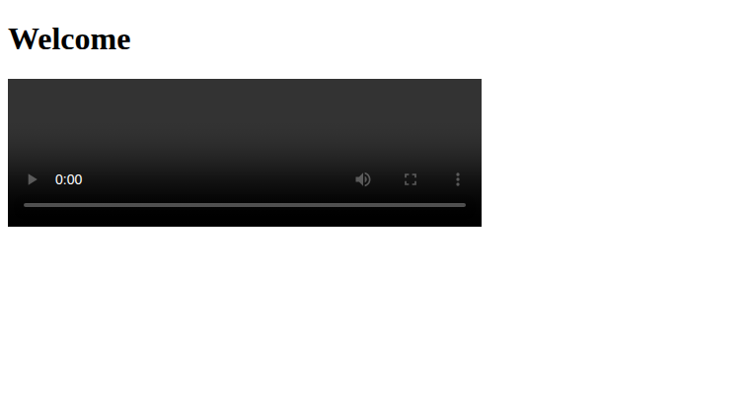

Question 2
Identify the appropriate HTTP method for form submission and explain why.
Answer: Option B, POST.
Justification: POST sends the form data in the body of the HTTP request, so the data does not appear in the URL, browser history or server access logs. This is required for registration, where personal data and a password are sent to the server. GET appends the form data to the URL as a query string, which exposes the password, as shown in Figure 3. PUT and DELETE are REST methods for replacing or removing a resource; HTML forms do not natively send them. POST does not encrypt data by itself, so the application should also be served over HTTPS.
Code (register_post.html, correct method):
<!DOCTYPE html>
<html lang="en">
<head><meta charset="UTF-8"><title>Registration (POST)</title></head>
<body>
<h2>Register</h2>
<form action="/submit" method="POST">
<p>Email: <input type="email" name="email"></p>
<p>Password: <input type="password" name="password"></p>
<button type="submit">Register</button>
</form>
</body>
</html>

Code (register_get.html, incorrect method, for comparison):
<!DOCTYPE html>
<html lang="en">
<head><meta charset="UTF-8"><title>Registration (GET)</title></head>
<body>
<h2>Register</h2>
<form action="/submit" method="GET">
<p>Email: <input type="email" name="email"></p>
<p>Password: <input type="password" name="password"></p>
<button type="submit">Register</button>
</form>
</body>
</html>

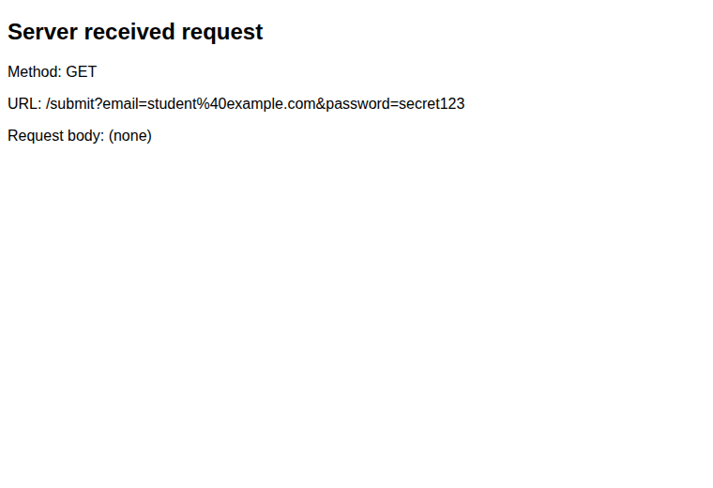
Form submitted with GET. The email and password appear in the URL.
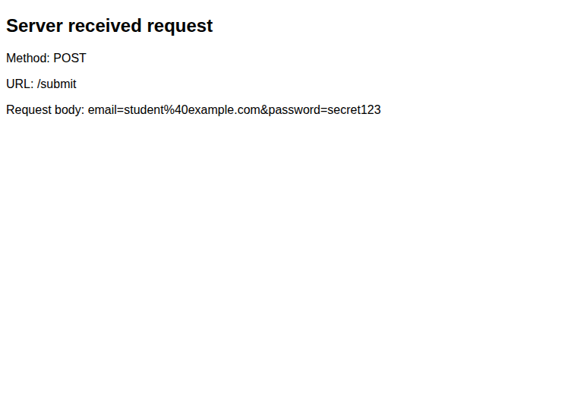
Form submitted with POST. The data is in the request body and the URL is clean.

Question 3
Choose the proper semantic element for navigation and justify its usage.
Answer: Option B, <nav>.
Justification: The <nav> element marks a block of navigation links. Its meaning is understood by browsers, search engines and assistive technologies such as screen readers, which allow users to skip directly to the menu.
Option A (<div>) is a generic container with no meaning.
Option C (<section>) groups thematic content within a page rather than navigation links. Option D (<header>) holds introductory content such as a logo or title, and it may contain a <nav>, but it is not the navigation itself.
Code (nav.html):
<!DOCTYPE html>
<html lang="en">
<head>
<meta charset="UTF-8">
<title>Semantic Navigation</title>
<style>
body { font-family: Arial, sans-serif; margin: 20px; }
nav ul { list-style: none; padding: 0; margin: 0; }
nav li { display: inline-block; margin-right: 20px; }
nav a { text-decoration: none; color: #000; font-weight: bold; }
nav { border-bottom: 1px solid #000; padding-bottom: 8px; }
</style>
</head>
<body>
<nav>
<ul>
<li><a href="#">Home</a></li>
<li><a href="#">Products</a></li>
<li><a href="#">About</a></li>
<li><a href="#">Contact</a></li>
</ul>
</nav>
<section>
<h2>Our Products</h2>
<p>Content of the page goes here.</p>
</section>
</body>
</html>

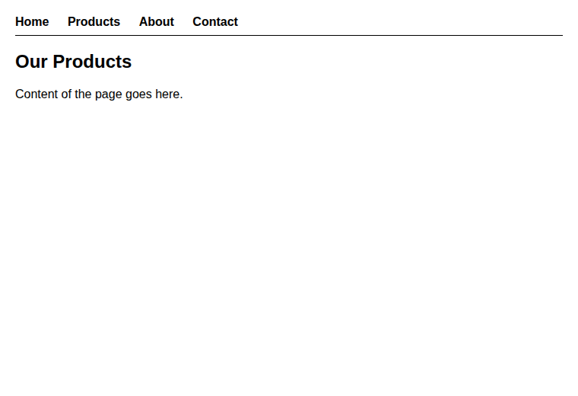

Question 4
Identify the correct XML syntax and explain the error in the other options.
Answer: Option B, <note><to>User</to><from>Admin</from></note>.
Justification: An XML document must have every element closed by a matching end tag, and the tags must be correctly nested. Option B meets both rules. Each option was saved as an XML file and opened in the browser, which reports any well-formedness error (Figure 5).
- Option A: the <note> element is never closed, because </note> is missing.
- Option C: the <to> element is closed with </from>. This mismatched end tag breaks the nesting, so the document is not well-formed.
- Option D: the closing tag </note is missing its final '>' character, so the tag cannot be read.
Code (option_a.xml to option_d.xml):
option_a.xml:
<note><to>User</to><from>Admin</from>

option_b.xml:
<note><to>User</to><from>Admin</from></note>

option_c.xml:
<note><to>User</from></note>

option_d.xml:
<note to="User"></note

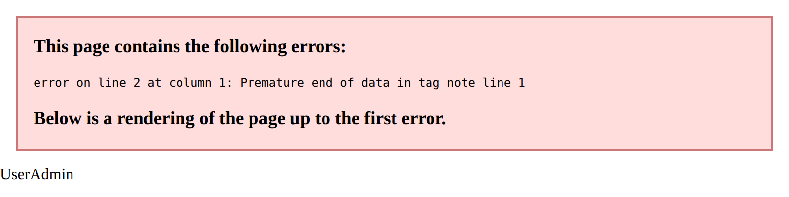  Option A | 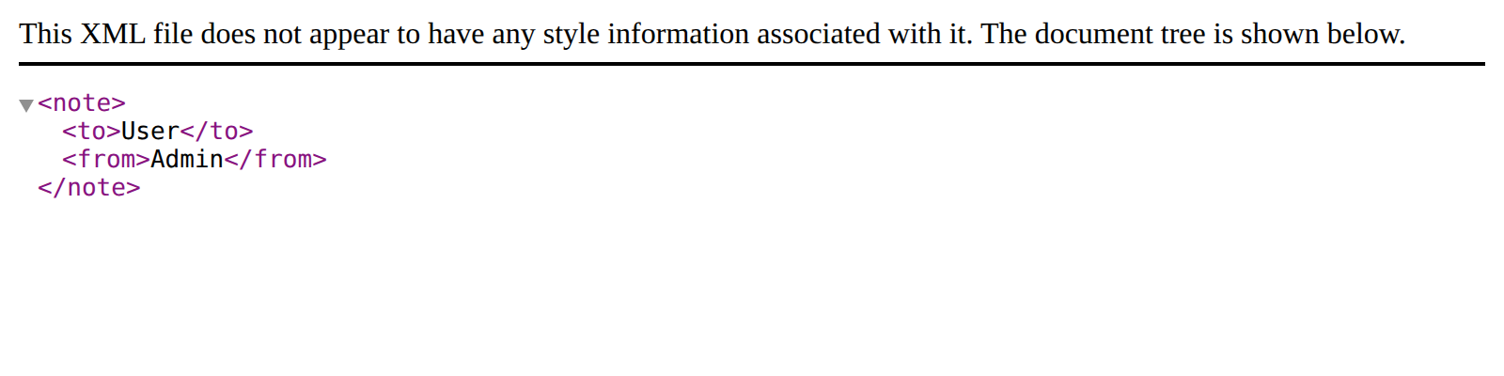  Option B
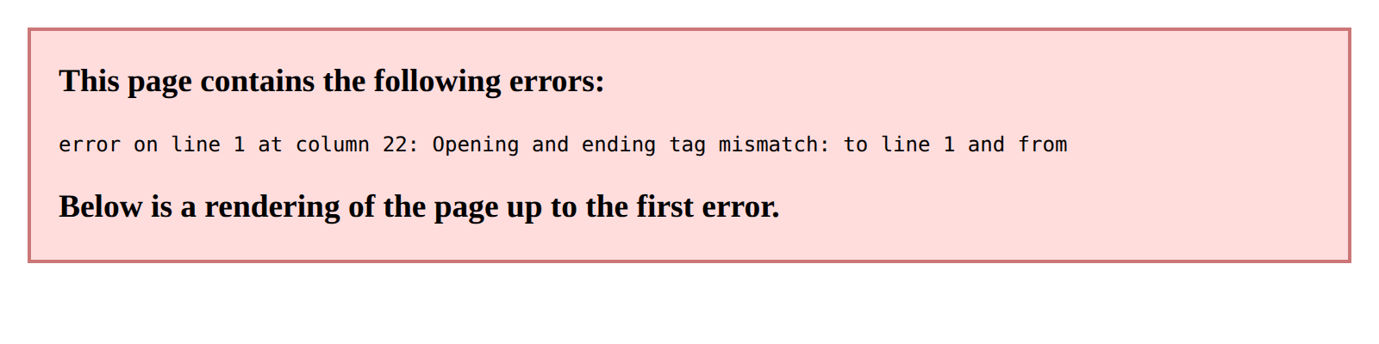  Option C | 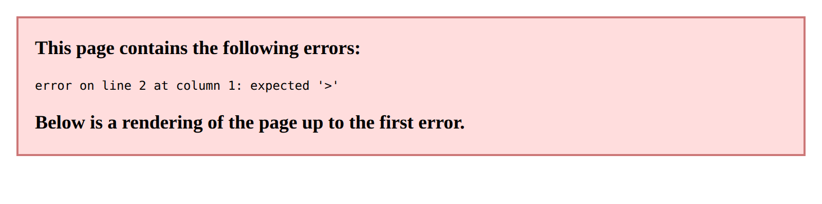  Option D
Figure 5: Browser output for each XML option. Only option B loads without an error.

Question 5
Choose the correct protocol for web communication and justify your choice.
Answer: Option B, HTTP (Hypertext Transfer Protocol).
Justification: HTTP is the application-layer protocol that browsers and web servers use to request and deliver web pages, images and form data. Figure 6 shows a real HTTP request sent by a client and the response returned by the server, including the status line 'HTTP/1.0 200 OK'. The other options serve different purposes: FTP transfers files between computers, SMTP sends electronic mail, and SNMP monitors and manages network devices. For production, the web application should use HTTP over TLS (HTTPS) so that communication is encrypted.
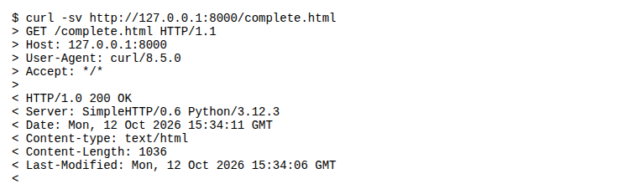
HTTP request and response captured with curl

Solution Design: Combined Code-Along Page
The corrected elements are combined into one page. The page contains a semantic navigation menu, the promotional video, and a registration form that submits with POST.
Code (complete.html):
<!DOCTYPE html>
<html lang="en">
<head>
<meta charset="UTF-8">
<title>CSA43 - First Web Page</title>
<style>
body { font-family: Arial, sans-serif; margin: 20px; }
nav ul { list-style: none; padding: 0; margin: 0; }
nav li { display: inline-block; margin-right: 20px; }
nav a { text-decoration: none; color: #000; font-weight: bold; }
nav { border-bottom: 1px solid #000; padding-bottom: 8px; margin-bottom: 16px; }
form p { margin: 8px 0; }
</style>
</head>
<body>
<nav>
<ul>
<li><a href="#">Home</a></li>
<li><a href="#">Products</a></li>
<li><a href="#">Contact</a></li>
</ul>
</nav>
<h2>Promotional Video</h2>
<video src="video.mp4" controls width="400"></video>
<h2>Register</h2>
<form action="/submit" method="POST">
<p>Full name: <input type="text" name="name"></p>
<p>Email: <input type="email" name="email"></p>
<p>Password: <input type="password" name="password"></p>
<button type="submit">Create account</button>
</form>
</body>
</html>

